Roll no: 422171

Name: Lahari. K

Section: A

Assignment: 05

Task 2: Create a project under CVS/git repository and record multiple versions/branches and practice merging of branches (with a batch of 2 members) using gitbash commands and upload all your previous lab tasks to this repository.

Execution:

**Creating a github repository : -**

Commands to initialize a new Git repository in the project1 directory:

mkdir <project name>

cd <project name>

git init

After adding lab task files and directories, command to stage the changes made: git add .

command to commit the changes: git commit -m "Initial commit: Adding lab tasks"

commands to create different versions:

git checkout -b version1

git checkout -b version2

command to switch between the versions: git checkout version1

command to commit the changes made: git commit -m "Version 2 changes"

commands to merge the branches (if changes made in both branches):

git checkout master

git merge version1

git merge version2

commands to upload the local repository to a github repository (using repo’s link)

git remote add origin <repository link>

(provide PAT instead of password)

git push -u origin master

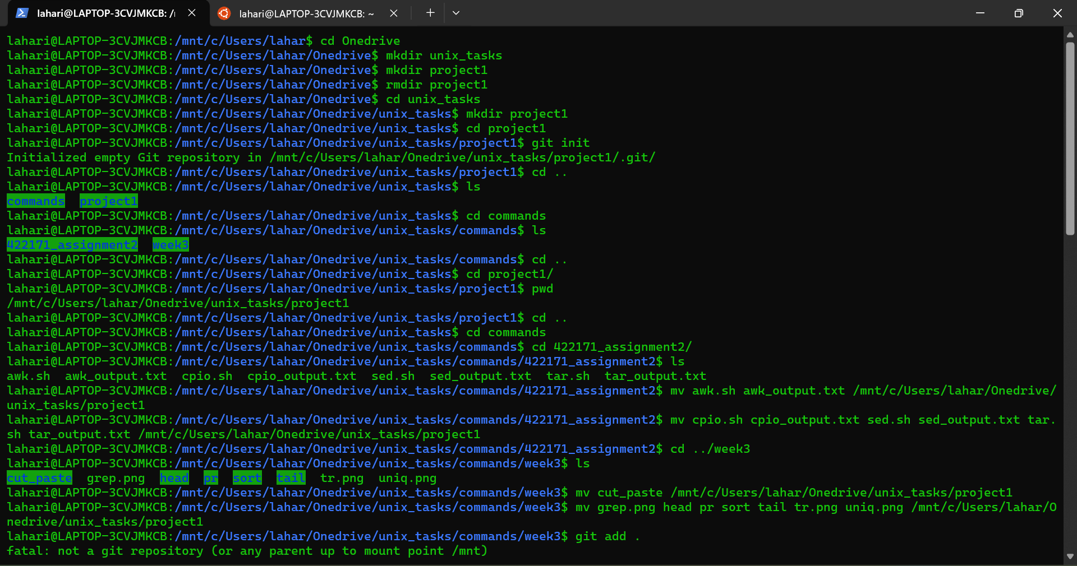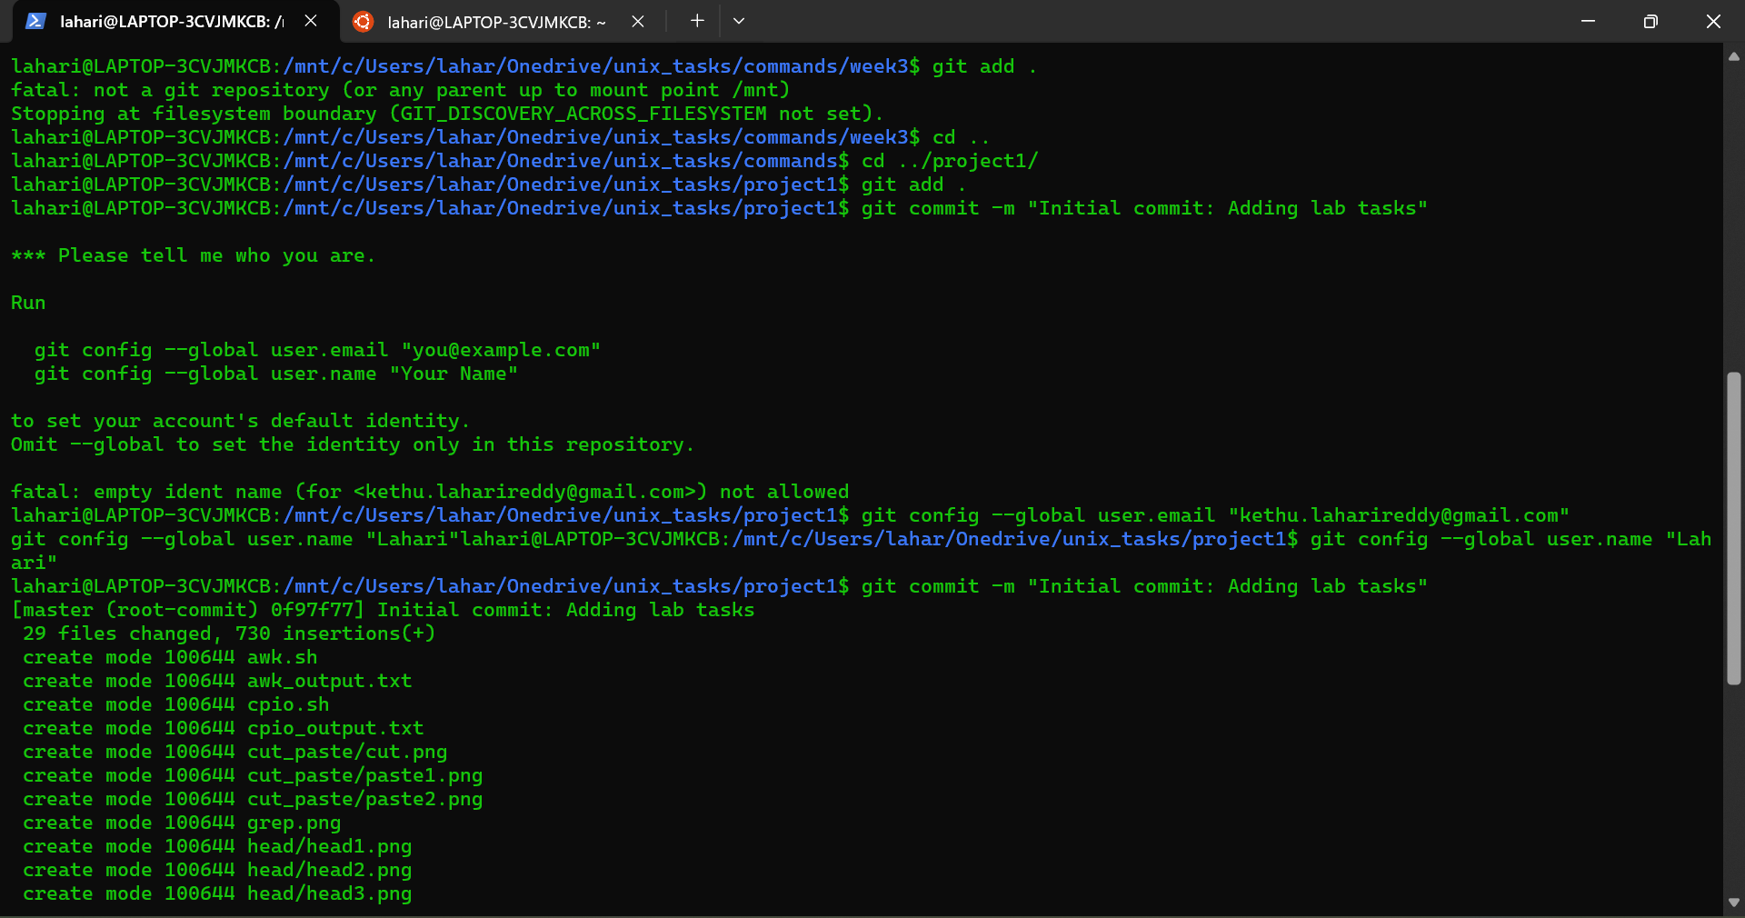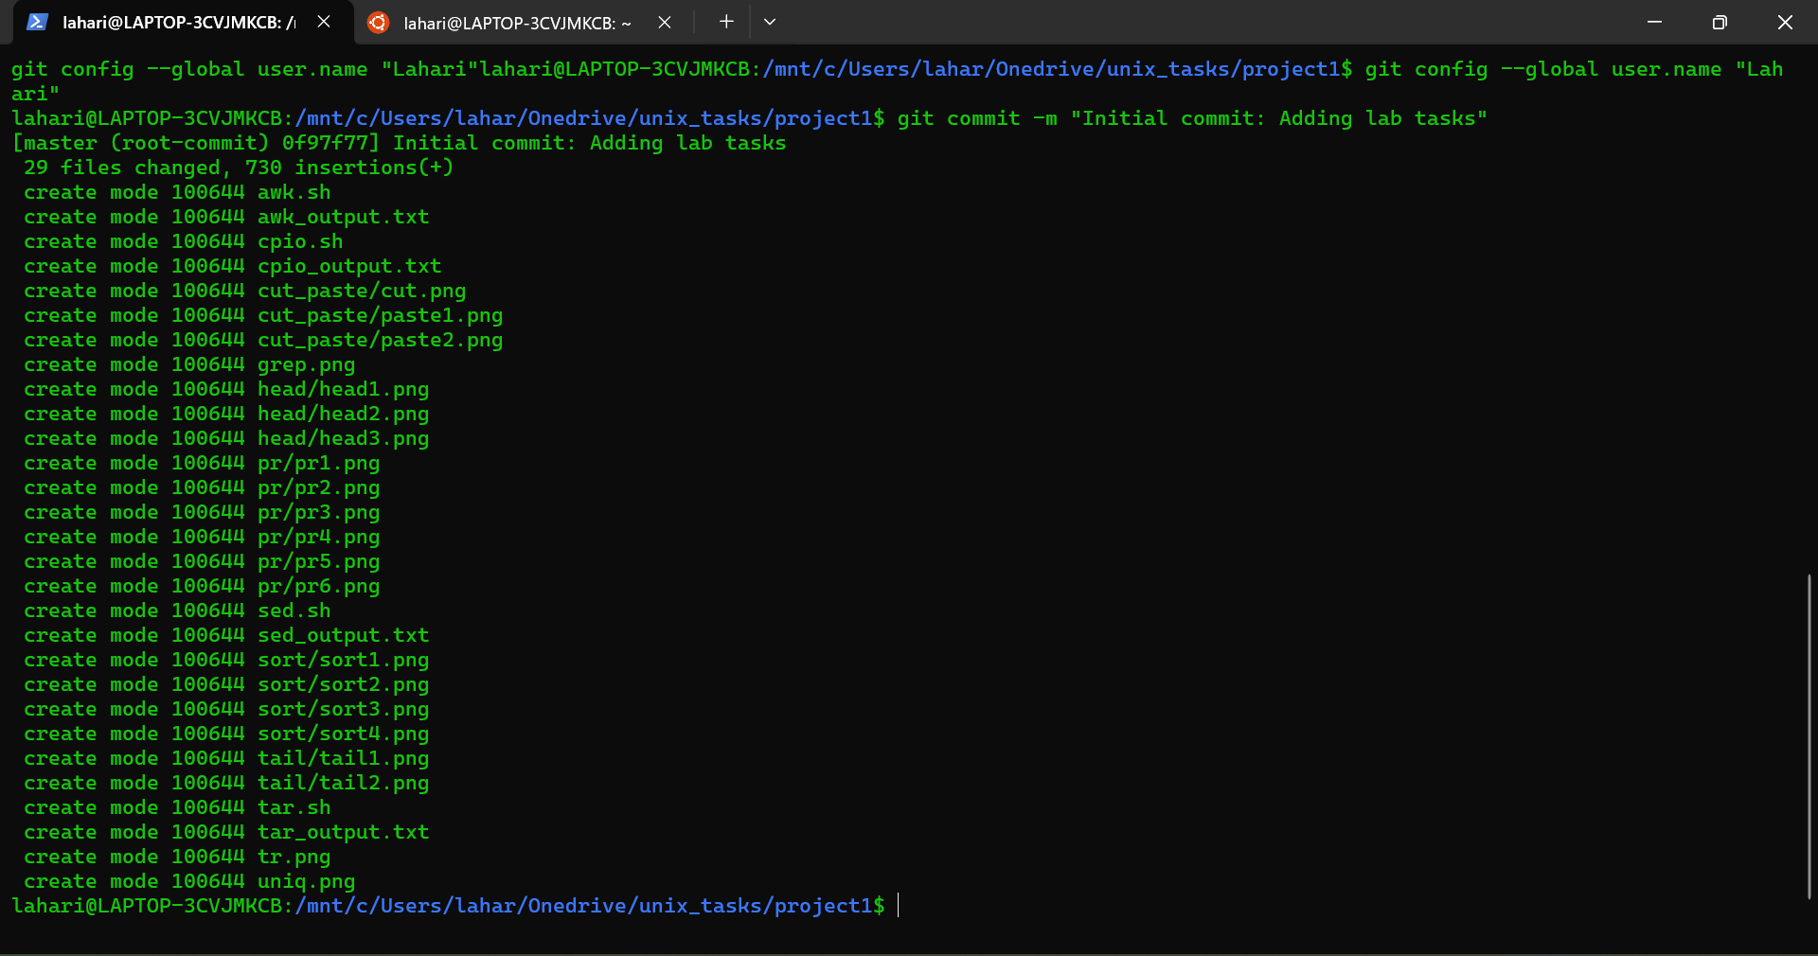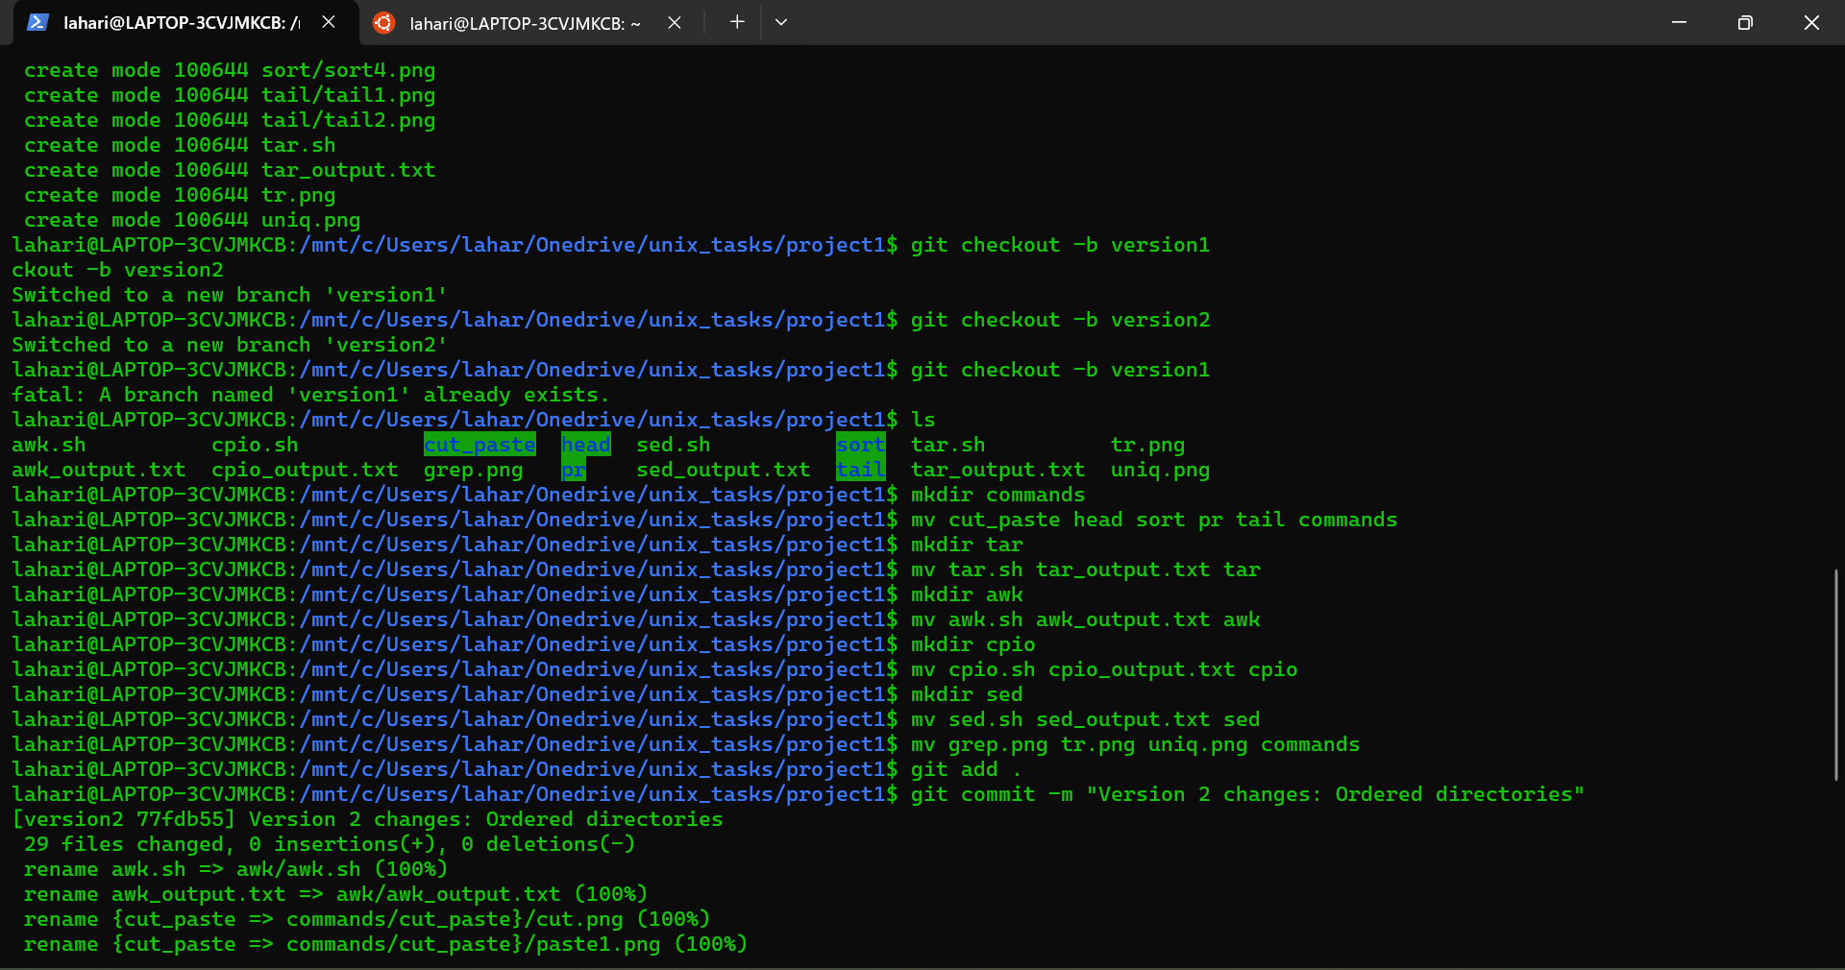

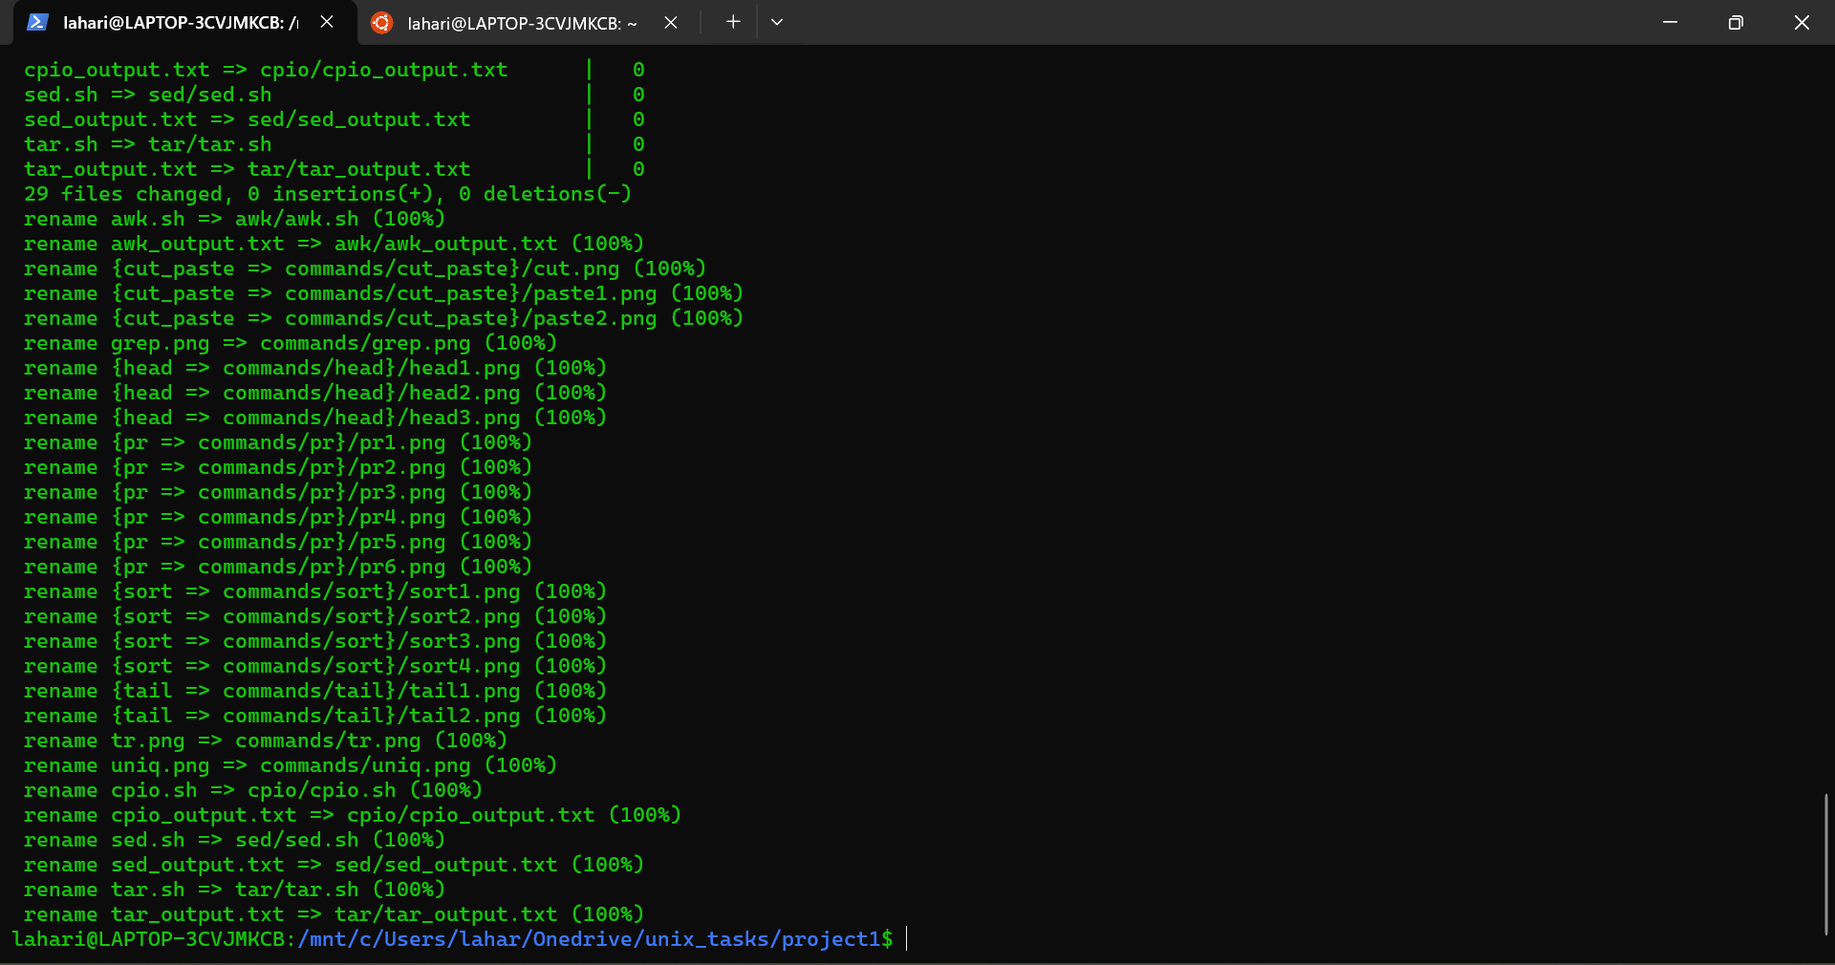

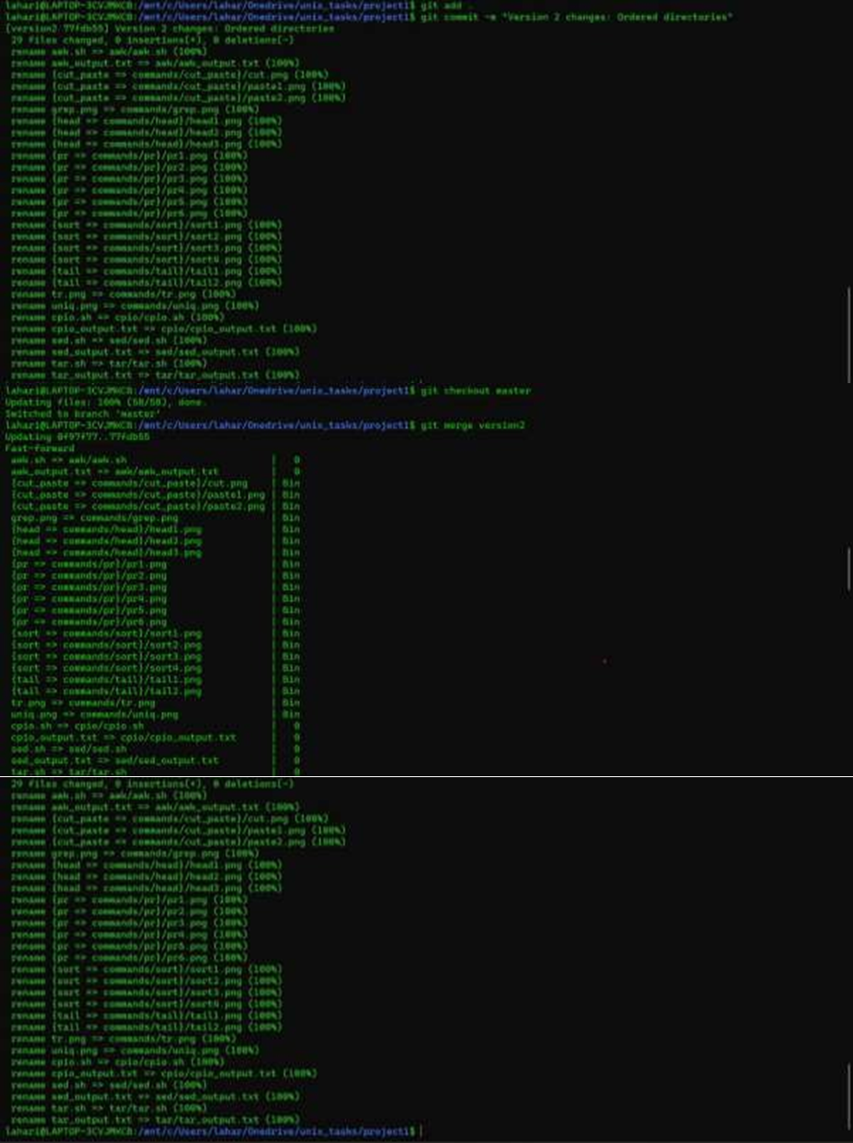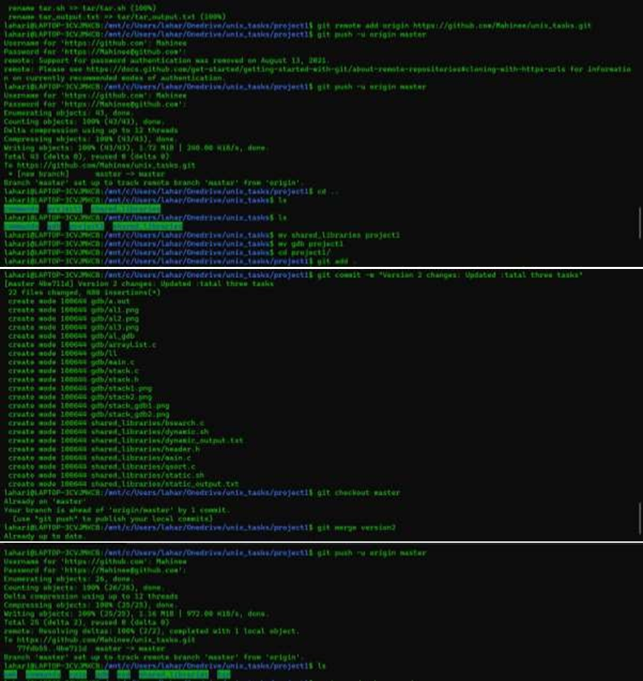

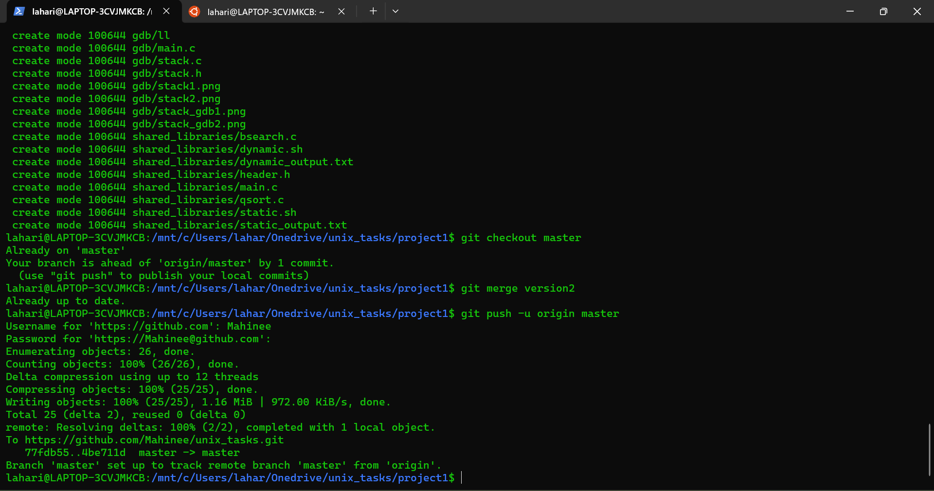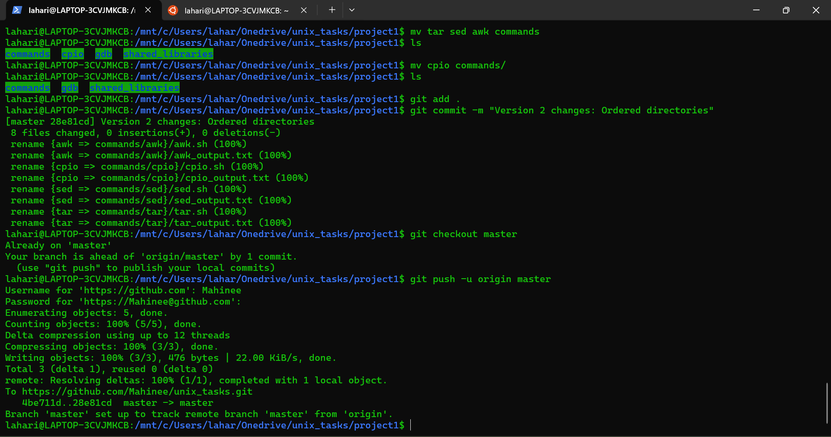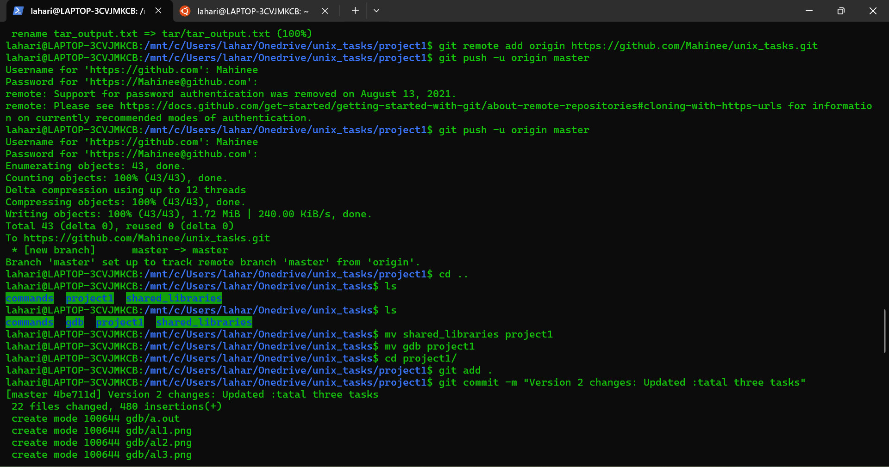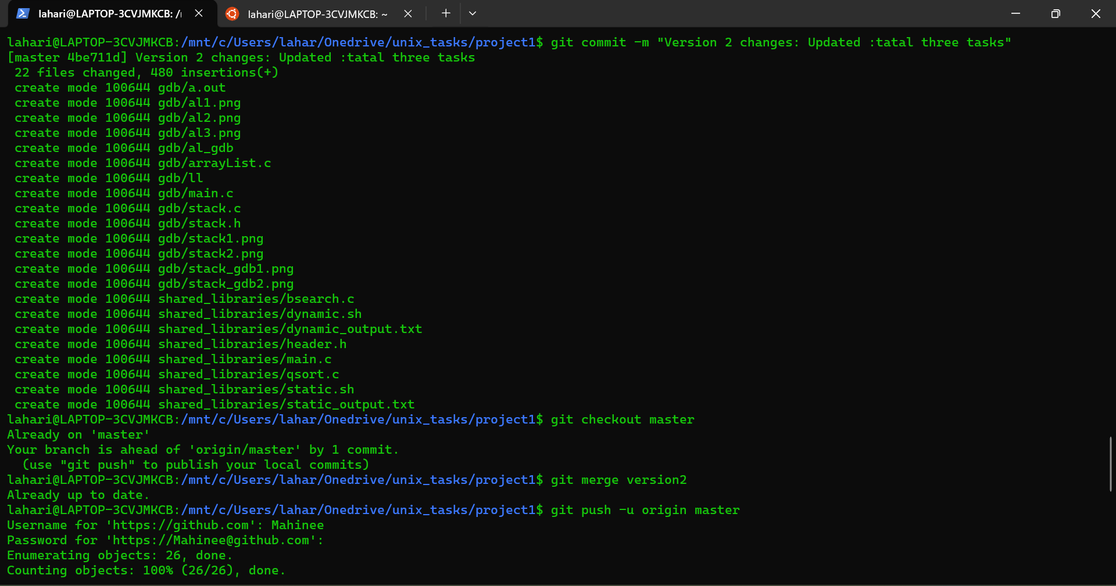

Explanation:

Created a directory project1

Made it a local repository and added lab tasks into it

Made two branches namely version1 and version2

Version1 was not altered but the directories were ordered in branch version2.

Committed the changes after staging.

Merged the version2 branch with master and uploaded the local repository to remote github repository.

Added two more lab tasks to branch version2, staged the changes, and committed them.

Again, the branch was merged with master and changes were uploaded to the remote repository.

**Cloning another’s repository :-**

Repository before cloning (original repository):

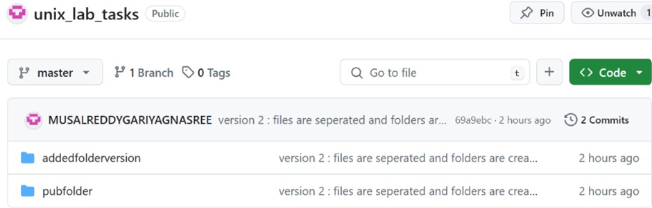

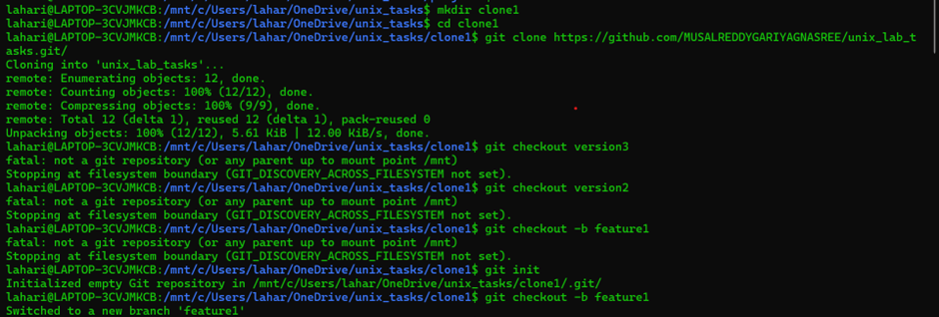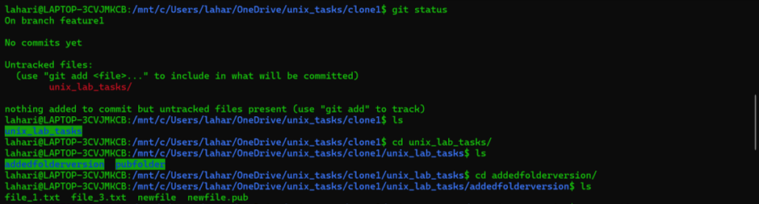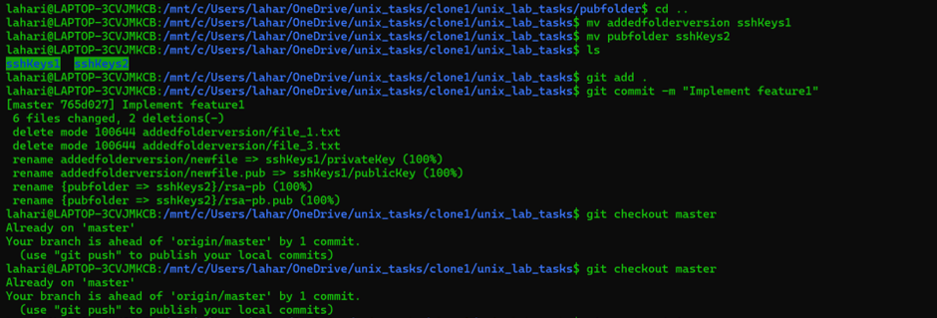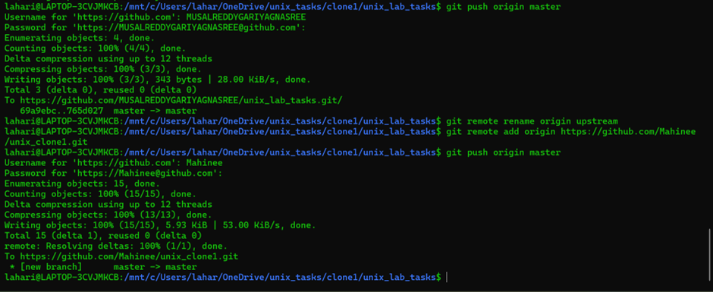

Repository after the changes:

